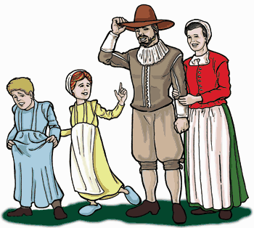
Colonial Quilt Project
This Photo by Unknown Author is licensed under CC BY-NC-ND
This Photo by Unknown Author is licensed under CC BY-SA

Design a “quilt” (see below) on a poster paper (no smaller than 11x17 and no bigger than 17x22) that shows how the groups of colonies are the same in 3 different categories (founder, reason founded, people, climate, geography, economy, religion, or politics). Use the information that we collected about the colonies (OneNote Social Studies tab-Chart of Colonies) and in the Social Studies Book in CH 4 lesson (p 138-178).
- Be sure to write the name of each category at the top of the quilt and the names of the colony group on the side (see example below).
- The squares of the quilts should mainly be decorated with pictures, but words can be used as well.
-To make your quilt look more real, feel free to use cutout paper, yarn, buttons, or other materials that you have at home.
Category 1 | Category 2 | Category 3

New
England
colonies
Middle
colonies
Southern
colonies

New England
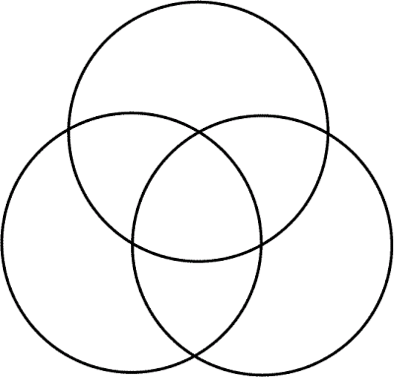
Part 2 Triple Venn Diagram
On the back of the poster, complete a triple Venn diagram comparing the colony groups (New England, Middle, and Southern). In the parts of the circle that overlaps with other circles, place information that is similar between the two groups. The center, where all the circles overlaps is where the similarities between all the groups is recorded. The part of the circle that does not overlap with any other circle is for the information that is only about that group and is different from other groups.
Southern
Middle

